**ANALYZING CANCER DATA USING POWER BI - JASMINE**

**Requirement 1: Analyse the prevalence of gene mutations in cancer patients by age group in the UK**

Gene mutations in cancer patients exhibit varied prevalence across varied age groups in the UK due to distinct genetic susceptibilities and cumulative environmental exposures. To analyze the current scenario, I have written DAX queries for calculating Gene mutation count and Gene Prevalence Status based on the varied age groups. The below insight will show the prevalence of gene mutations based on age -groups.

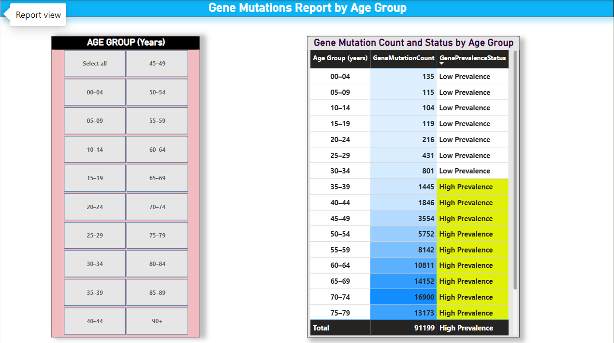

**Fig. 1**

**Requirement 2: Analyse the Number of Cancer patients by vital status from 2016 to 2019 for the UK**As per the requirement, an analysis of the count or distribution of cancer patients in the UK over the years 2016 to 2019 needs to be conducted. The patients must be categorized based on their vital status, i.e., dead or alive during that time frame, to examine and compare the number of cancer patients in the UK over this period.

To fulfil this requirement, I plotted a Pie chart and calculated the DAX queries for dead patients. However, I couldn't acquire the data for alive patients from 2016 to 2019. Therefore, instead of displaying the dead and alive patient data, I analysed and compared the count or distribution of cancer patients across five categories over the years 2016 to 2019.

For instance, I considered data on cancer patients categorized by stages, types of treatment received, age groups, or other relevant factors. I counted the number of patients available for each category for which the data is present and plotted the pie chart, as shown in the below insight.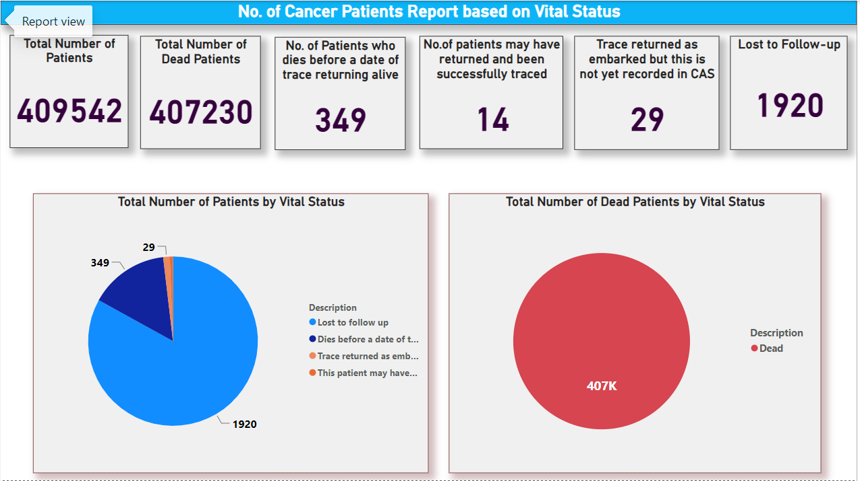

**Requirement 3: Analyze the number of patients for each cancer type, and add year as a filter in UK**Analyzed the number of patients for each cancer type and wrote the DAX query for Cancer Cases UK and got the below insight.

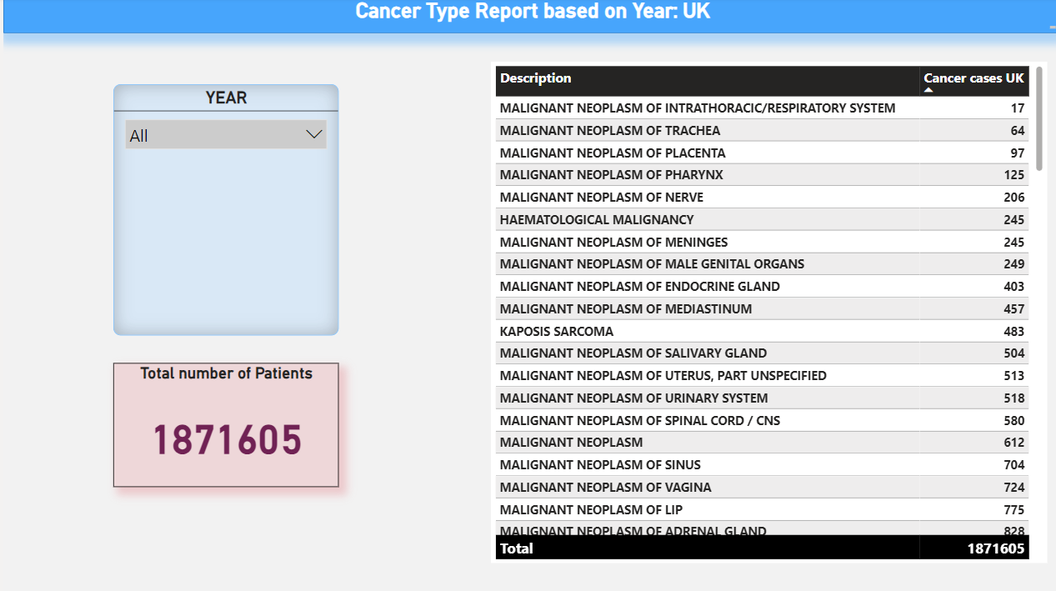

**Requirement 4: Analyze and compare cancer incidence by year and age group between AUS and the UK**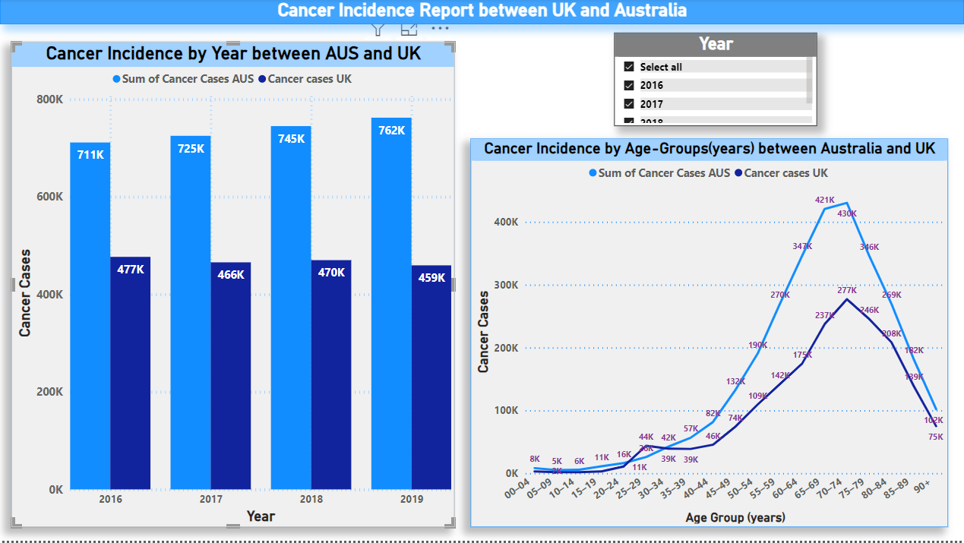

**Requirement 5: Visualize the proportion of all ethnic groups among non-British male patients.**